Negative Prompting with SD 2.x

In stable diffusion 2.x negative prompting got much more prominent and useful and important as before.

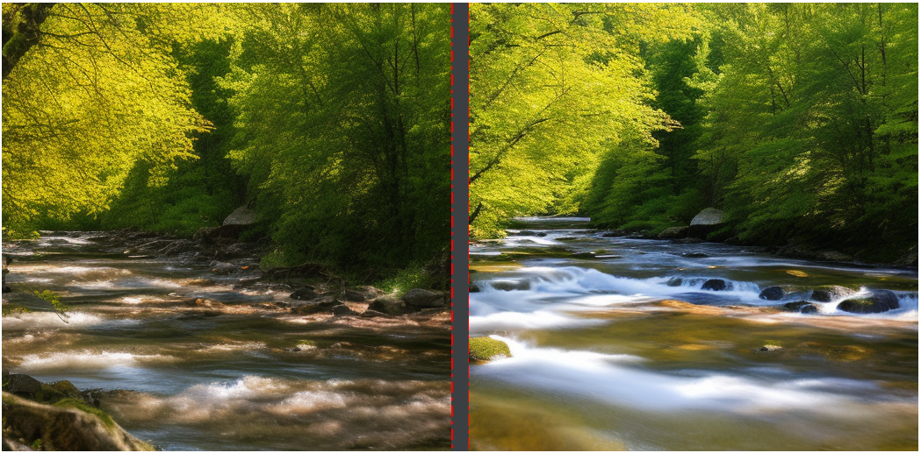

This is the same prompt using the same seed at 40 Steps Euler A.
Left is with no negative Prompt and right is with negative Prompt:
Prompt is: A highly detailed photo of a river in the forest ad a nice sunny afternoon
Seed is: 259764047
Negative Prompt is: Ugly,Morbid,Extra fingers,Poorly drawn hands,Mutation,Blurry,Gross proportions,Missing arms,Mutated hands,Long neck,Duplicate,Mutilated,Mutilated hands,Poorly drawn face,Deformed,Bad anatomy,Cloned face,Malformed limbs,Missing legs,Too many fingers, fog, darkness, grain, watermark
Negative prompt might be to much but it was more easy to just use all of it instead of fiddeling out which one is the right negative for this prompt. Important here is to show the large difference we get with using negative promting with 2.x. Model used here is 2.0 512-base-ema.ckpt

A list of helpful negative prompt is this:

Ugly, Morbid, Extra fingers, Poorly drawn hands, Mutation, Blurry, Gross proportions, Missing arms, Mutated hands, Long neck, Duplicate, Mutilated, Mutilated hands, Poorly drawn face, Deformed, Bad anatomy, Cloned face, Malformed limbs, Missing legs, Too many fingers, Fog, Darkness, Grain, Painting, Fake, Drawing, Grainy, Pixels, Specks, MSPaint, Multiple heads, Multiple limbs, Disfigured, Letters, Words, Signs, Signatures, Lowres, Low quality, Fused legs, Anime, Bad-artist, Bad-artist-anime, Loli, Simple background, Text, Logo, Multiple girls, Chinese lantern, Bad-hands-5, Simple background, Artist name, Censored, Censor_bar, Text font, UI, Error, QR code, Bar code, Censored, Cropped, Worst quality, Signature, Watermark, Username, Split screen, Onoff, Hat, Cat ears, Hair bun, Hood, 2girls, Selfie, Out of frame, Long hair, Mole, Cameltoe, Large breasts, Huge breasts, Gun, Alien creature, QR code, Bad proportions, Extra limbs, Fewer digits, Bad fingers, Fingerless, Fused hands, Fused limbs, Fused fingers, Two girls, Long legs, Elf ears, Photo, DSLR, 3D, Cell shading, Octane render, CGI, Unreal engine, Halo, BREAK, Bikini, Thong, Midriff, Naked, Dakimakura, Car ears, Holding hands, Daytime, Upskirt, Holding item, Holding gun, Holding sword, Shooting, Sunlight, Tail, Giant, Giantess, Toddler, Woman, Girl, Skirt, Dress, Thighs, Nipples.

There is also a negative textual inversion that helps make 2.x images look better. The original can be found here https://huggingface.co/datasets/Nerfgun3/bad_prompt
But the file are in documentation/negative prompt so you just have to put them into the embedding folder.
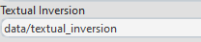
You can setup the folder in System Settings

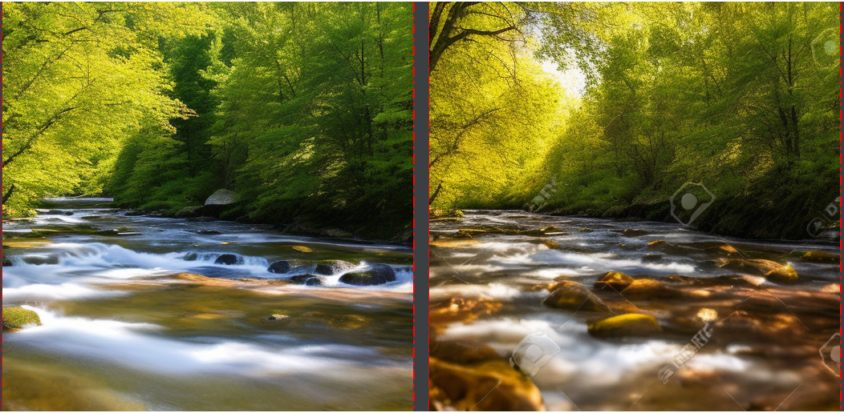
On the right we see the effect of the negative textual inversion, other then our negative prompt it did not remove the watermarks, so Manual negative prompting might be the better solution.
A combined negative prompt plus the negative textual inversion produces this result
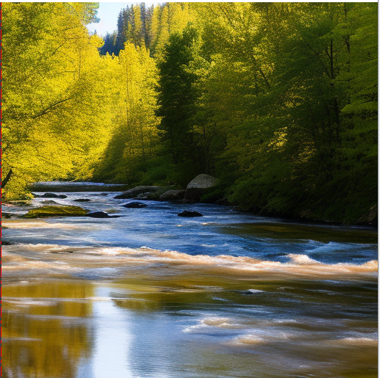
The water looks a little better, in my view, as with just the negative prompt, so the negative textual inversion seems to be at least a good add on to the negative prompt

